DATA SHARING & PROTECTION

Data can be shared securely in snowflake
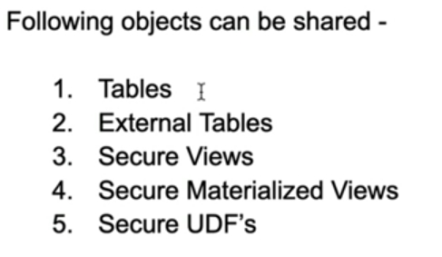
Once the data is actually shared to different accounts, It is read only i.e. the consumers who are accessing your data is only to read, they cannot change it
This is all handled by Meta data and no real data is getting transferred & it is very easy to set up

Snowflake achieves data sharing by a concept called ‘shares’
Here, the data provider creates and give access on it to data consumers
Share:
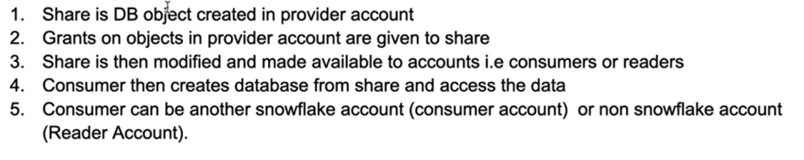

Pictorial representation of data sharing using shares
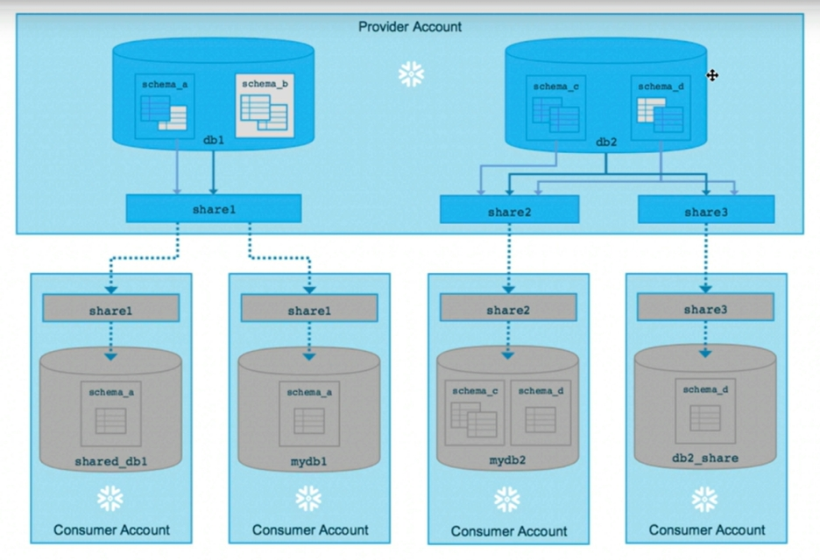
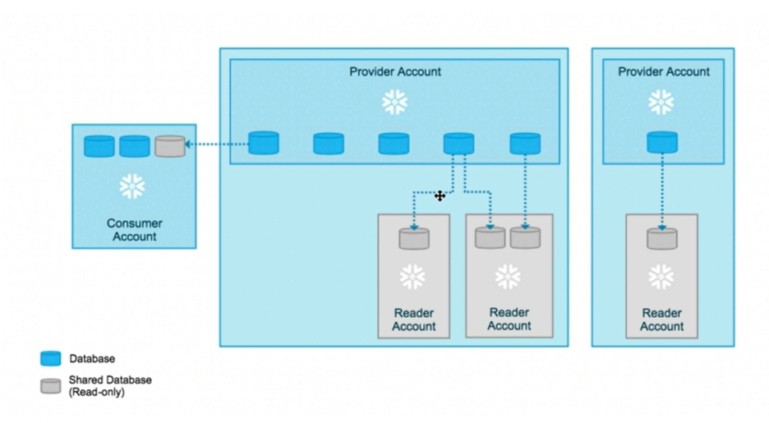
Let’s do some hands on
Give grants in warehouse, DB and Schema to public
